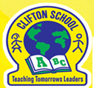 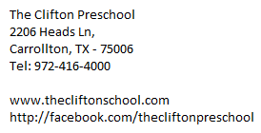

**Social Media Photo Release Form**

We ask your permission to post photos of your child and their work on our Facebook page.

Please check below to give us your consent:

_________**Yes**, I give permission for my child to be photographed during class-related activities and events

_________**No**, I do not give permission for my child to be photographed during class-related activities and events

________ **Yes**, I agree to give Clifton School permission to post photos of my child on social media

________ **No**, I do not give Clifton School permission to post photos of my child on social media

Child’s name: ____________________________

Parent/Guardian’s Sign: ___________________

Date: _______________

Please go on Facebook and like the page “Clifton Preschool”. Thanks so much for your support.